**DER ES SALAAM INSTITUTE OF TECHNOLOGY**

**DEPARTMENT OF COMPUTER STUDIES**



**NAME:** MOHAMED OMAR MOHAMED.

**REG NUMBER:** 170240220179.

**SUBJECT:** DIGITAL SIGNAL PROCESSING.

**CLASS:** BENG-17 COE-1.

**CLASS ASSIGNMENT**

QN 1 : 🡪The information contained in the input signal x(t) is an analogue information contained in an input signal x[t]

🡪The changes that the y[t]=H [x(t)]

🡪is an analogue time output signal

QN 2:

1. Mathematical expression

x(t)=Asin(wt+f)

1. Continuous (Analogue)

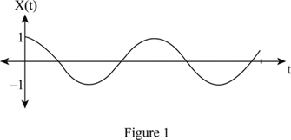

1. Discrete (Digital)

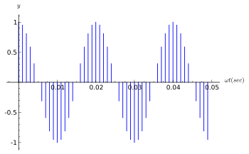

1. Periodic

x(t)= x(t+T0)

Period = T0

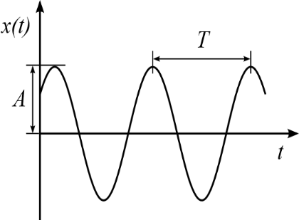

1. Aperiodic



1. Even signal





1. Odd signal



1. Causality

Analogue signals: x(t) = 0 for t < 0

Analogue signals: x(t) = 0 for t < 0

1. Energy



1. Instantaneous Power



1. Average Power



1. Power Ratio



1. Convolution between two signals



QN 3

1. Dirac delta function (Impulse or Unit Response) d(t)

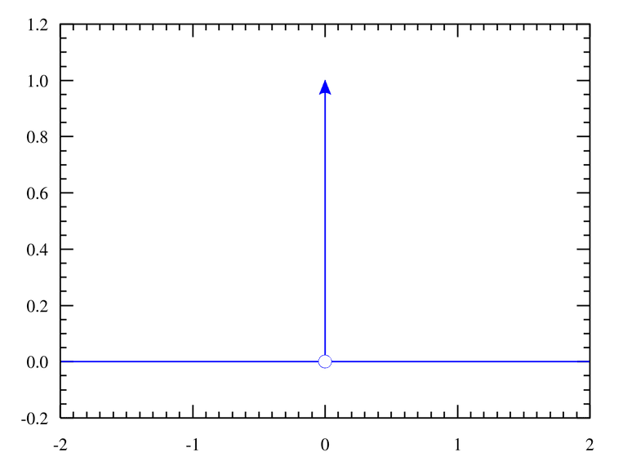A function that is zero in width and infinite in amplitude with an overall area of unity.



Where 

1. Step function u(t)

A function that increases or decreases abruptly from one value to another



[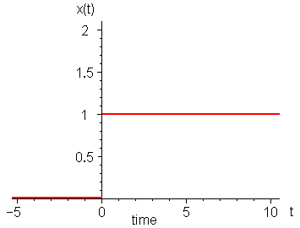](https://www.google.com/url?sa=i&rct=j&q=&esrc=s&source=images&cd=&cad=rja&uact=8&ved=2ahUKEwivhPDO06niAhVi5OAKHVl9DRoQjRx6BAgBEAU&url=/url?sa=i&rct=j&q=&esrc=s&source=images&cd=&ved=&url=https://dsp.stackexchange.com/questions/7677/sampling-a-unit-step-function&psig=AOvVaw0eStHUtvlMCBIY658SaReT&ust=1558426010525532&psig=AOvVaw0eStHUtvlMCBIY658SaReT&ust=1558426010525532)

1. Impulse function: zero width and infinite amplitude

is a pulse that is much shorter than the time response of the system, The system's response to an impulse can be used to determine the output of a system to any input using the time-slicing technique

 

1. Discrete Impulse function

A function that takes a value of one at a time n=0 and value of 0 elsewhere



1. Step function: A step response



1. Discrete Step function



QN 4

1. Linearity

Is a function that can be graphically represented as a straight line

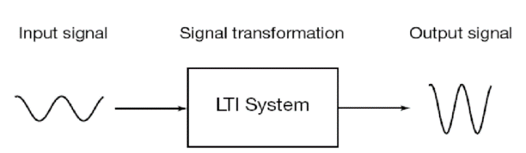

1. Homogeneity

A system is said to be homogeneity if an amplitude change in the input results in an identical amplitude change in an output. That is if x[n] results in y[n], then kx[n] results in ky[n] for any signal x[n] and any constant k

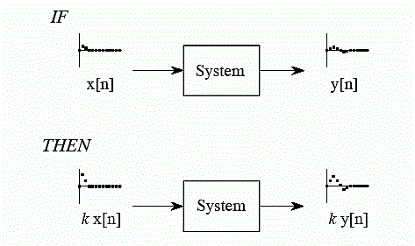

1. Time-invariance: System does not change with time

System does not age, its parameters are constant

**System**

x[n] y[n]

**System**

x1[t-t] y1[t-t]

x[t] y[t]

t t

x[t-t] y[t-t]

1. Time-invariance: Discrete signals

**System**

IF X[n] y[n]

Then X[n-m] y[n-m]

**System**

X[n] y[n]

t t

x[n-m] y[n-m]

1. Stability

The output of a stable system settles back to the quiescent state (e.g., zero) when the input is removed

The output of an unstable system continues, often with exponential growth, for an indefinite period when the input is removed

1. Causality

Response (output) cannot occur before input is applied, ie.,

*y*(*t*) = 0 for *t* <0