## INTRODUCTION

The key to getting the best sound production studio is to first figure out what is it that you are really want to achieve with it. Are looking to only record your music or planning to turn the studio into a business?

You also need to know if you will be using the studio for mixing and mastering as well or not. So before getting into the guide, figure out what type of studio you want. Once you have that figured out then you have half of the job done. The next thing will be getting the right gear and a pro setup to ensure that you get the best results.

Even if you are not sure about what type of sound production studio you want, in this guide, I will show you how easy it is to build a professional sound production studio.

The following are the requirements to invest on a new Sound Production Studio:

## A COMPUTER OR A LAPTOP

These days almost everyone has a computer or their households a laptop. Most of computers and laptops that are being released are good enough for you to get started right away. If ever you will need to upgrade then you can do it later. Feel free to get started with what you already have, it should do the job.

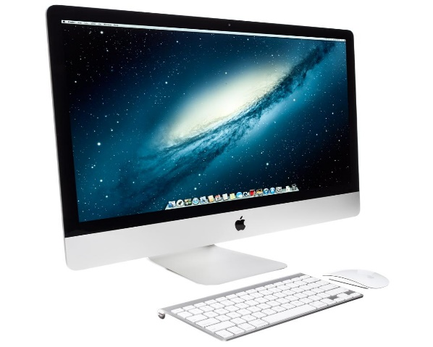

Figure 1 COMPUTER

## DAW OR MUSIC SOFTWARE

A Daw is basically a “**Digital Audio Workstation**” or the music software that you use for recording, producing, mixing and mastering. Honestly, they all do the same thing. Even Propeller head Reason can now support third party VST plugins and instruments. So it’s just matter of preference and what you feel comfortable with. Almost all music software will have a demo or trial version, check out a few, read the tutorials and go with what seems easy for you. Choose any DAW but if you are struggling with that then check out DAWs that I recommend.

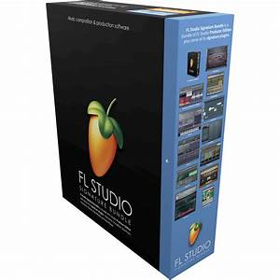

Figure 2 DAW or MUSIC SOFTWARE

1. Stenberg Cubase.

Cubase is one of the oldest digital audio workstations developed by Steinberg which is a German musical company.

1. Avid Pro Tools.

Pro Tools was developed by UC Berkeley graduates, Evan Books and Peter Gotcher. It was introduced in 1994 under the name Sound Designer.

1. Apple Logic Pro X.

Logic Pro is the only DAW in this list that is not compatible with windows computers it works on Apple computers ONLY.

## AUDIO INTERFACE

If ever you going to be recording sounds or use studio monitors then you will definitely need an audio interface. If you just want to make beats, then the interface is not necessary. But don’t the mistake of buying an analogue mixer without an audio interface. That is a BIG new mistake. You will never capture/record a proper sound by plugging the Microsoft directly into the mixer then straight to your on-board PC soundcard. Rather get an audio interface without a mixer. Getting both has a huge benefit and flexibility. Point is, getting a mixer alone is just waste of time.

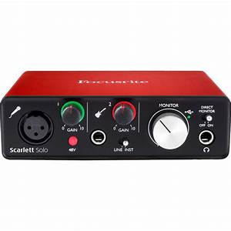

Figure 3 AUDIO INTERFACE

Best Audio Interface for recording studio.

1. M-Audio 2-Channel M-Track 2X2.
2. Native instruments Komplete Audio 6 USB Audio Interface.
3. Ronald Quad Capture Audio Interface.
4. M-Audi Fast Track Ultra.
5. Focusrite Scarlett 2i4 (2nd Gen).
6. Steinberg UR22MKII 2-Channel USB Interface.
7. Mackie Onyx Blackjack.

## STUDIO MONITORS

To make sure that your music competes with other commercial records then you will need a good audio output system. Studio monitors are the best audio output device for a recording studio because they produce a great neutral sound that is not colored. Commercial and desktop speakers have a colored sound so that they can sound good for consumer. So the sound you hear from commercial speakers is exaggerated that is why they are not recommended for studio work. Make sure you get pair that will help you get pro sounding music.

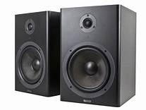

Figure 4 STUDIO MONITOR

## MICROPHONES

Each and every recording studio must have at least 3 or more microphones. Simply get 2 good condenser mics and 1 dynamic mic then you are good to go. If you know that you want from microphone then choosing one should not be a big issue. You will eventually get more mics in time as you upgrade your studio.

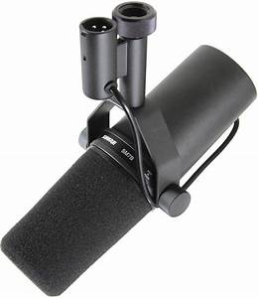

Figure 5 MICROPHONE

## HEADPHONES

A pair of headphones can come in handy in the studio for many reasons. Such as during the recording process, if you want to listen to your song in a different sound device or maybe you don’t want to make noise at right. Headphone can be really important when you don’t have a well acoustic treated room. Doing mixing with studio monitor headphones will give you a better sound than using a studio monitors in room that has no acoustic treatment.

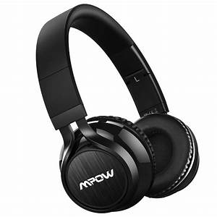

Figure 6 HEADPHONE

## CABLE

You are going to need cables to connect your equipment. Make sure you get the right size to ensure longevity because stretched short cable never last long and break easily. You will need basic cables for your studio monitors, MIDI controller and microphones. You might also need some cable extensions in case the cables that come with equipment are too short for your setup. So be prepared to invest in some good cables, don’t go cheap or buy thin cables.

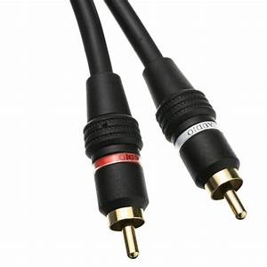

Figure 7 CABLES

## MICROPHONE STAND

Microphones do fall off cheap mic stands so make sure that you get a good solid mic stand, never go too cheap. Microphones stands are useful tools to have in the studio especially if you are recording multiple instruments such as drums, guitar amps, piano, string etc. They are not used for vocals but come really handy when recording a lot of multiple sounds. A cheap stand can also ruin a great performance so avoid that by all means.

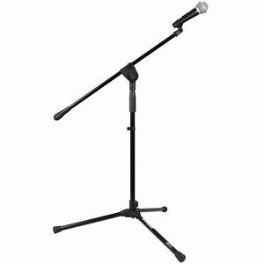

Figure 8 MICROPHONE STAND

## POP FILTER

A pip filter will come in handy during recording vocals. Just like mic stands, newbies tend to think that pop filters are all the same. It always good to have at least 2 different pop filters because vocalist are different. 1 will do the job when you are just starting out but it’s always good to test different pop filters during recording to figure out which one works best for the particular artist you are currently working with.

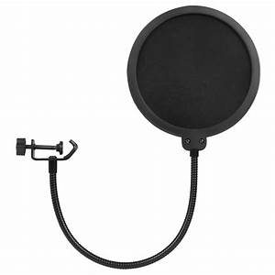

Figure 9 POP FILTER

## MIDI

MIDI is basically short “**Musical Instrument Digital Interface**”. The benefits of MIDI is that you can use 1 MIDI controller to play many different instruments. It’s unlike buying a guitar or grand piano which will limit you to only one sound. The world of MIDI has gone to another level since it began in the ‘80s. These days we have drum machines, keyboards, live drum kits guitar and more instruments will definitely be introduced in the future.

## CONCULUSION

Ok those the 10 essential tools for a professional sound studio setup. If you have all those 10 essential things then you are ready to make some really good music. One thing you have to avoid is to go too cheap when getting your equipment. You have to know what you want to use the equipment for then will always choose something that will benefit your art.