**DIGITAL VIDEO PRODUCTION**

1. **Introduction**

Video production is the process of creating video by capturing moving images (videography), and creating combinations and reductions of parts of this video in the process of production.

Video can be a compelling, informative and entertaining way to present your company, brand and product. But how do you start? What does it take? How do you get from idea to finished product?

There are three phases of video production:

1. Pre-Production
2. Production
3. Post-Production
4. **Pre-Production**

*Pre-production* is a fairly loose term which refers to the tasks undertaken before production begins. Exactly what is included in this stage depends on the medium and situation.

For a small video company, pre-production may refer to everything that happens before shooting begins, for example, meeting with the client, research, storyboarding, location planning, etc.

For feature films, pre-production is more specific and only begins when other milestones have been met such as financing, screenplay, casting and major staffing. In this case pre-production includes:

1. Location scouting
2. Prop and wardrobe identification and preparation
3. Special effects identification and preparation
4. Production schedule
5. Set construction
6. Script-locking (semi-finalization of the script)
7. Script read-through with cast, director and other interested parties
   1. **Filming Location**

A filming location is a place where some or all of a film or television series is produced, in addition to or instead of using sets constructed on a movie studio backlot or soundstage. In filmmaking, a location is any place where a film crew will be filming actors and recording their dialog. A location where dialog is not recorded may be considered as a second unit photography site. Filmmakers often choose to shoot on location because they believe that greater [realism](https://en.wikipedia.org/wiki/Realism_(arts)) can be achieved in a "real" place; however, location shooting is often motivated by the film's budget. Many films shoot interior scenes on a sound stage and exterior scenes on location.

It is often mistakenly believed that filming "on location" takes place in the actual location in which its story is set, but this is not necessarily the case.

* + 1. **Location scouting**

Selecting the right location is the first step on the road to a successful shoot.

There is unforgettably disastrous shoot, where the SD card filled up or the battery died at exactly the wrong moment, and it is never to let it happen again. But there's one kind of readiness you might not have thought of, and it is as essential as spare SD cards and batteries. That is scouting locations, a vital pre-production step that will help you meet almost any challenge when you shoot video in the field. Here are several tips that will help you as you scope out potential video shooting locations.

* + - 1. **Know your script**

Choose a site that *matches the setting of your story*. This is the first rule of location scouting. As you set out to evaluate locations, you'll likely face countless possibilities: *natural areas*, *historic sites*, *distinctive buildings*, *urban landscapes* and *waterfront settings*, to name a few. Remember, above all, that you have a story to tell. Choose a location that lends itself to the story you want to produce. You should never be bound by your locations. Locations are simply raw materials. You need to know what the script demands before you can select a suitable location.

* + - 1. **Scout at the right time**

Be aware that locations can change. It's wise to check your spot on the day of the week and the time of day that you'll be taping: these factors can produce surprisingly large changes on the suitability of a location.

Automobile traffic and noise, visitors to recreation and entertainment spots, and tourists at scenic or historic areas (to name just a few examples) all come in waves that vary dramatically based on the time of day, the day of the week and the season.

* + - 1. **Look at light.**

Churches, ballrooms, restaurants, auditoriums and homes generally feature low amounts of available lighting. Check light levels by shooting a few seconds of test footage with your camcorder.

Solutions for poor lighting might be as simple as scouting out window blinds and curtains that can be opened to add daylight. In some cases you may wish to bring in lights or ask permission to replace the bulbs in accessible light fixtures with brighter-burning units.

* + - 1. **Follow the sun**

Outdoor lighting conditions can be as challenging as those indoors; exterior illumination changes all day long. As you're scouting locations, pay attention to whether a given spot is in full sun, partial sun or full shade. Bright sun can be harsh on people's faces, and light-colored surfaces can blow out in full sunlight, causing automatic camcorder lenses to underexpose shots. Partial sun can be tricky, as well; today's camcorders, though sophisticated, can have trouble handling the high contrast in this situation. Ultimately, you may find that fully shaded locations or overcast days produce the most consistent results.

* + - 1. **Check for power supplies**

Many outdoor locations are far from power sources and even some indoor locations can pose AC challenges, so multiple camera batteries are always a good idea. But you'll still need to evaluate your power options at any location.

How will you power your lights? What if you do end up draining all your batteries? Is there anywhere to plug in the charger? Is the spot remote enough to make a car-lighter AC adapter a good idea? In a location that does have power, you may be able to plug in, but you'll still need to think about the system's pre-existing load and whether or not you can get to the fuse (breaker) box in case something blows.

* + - 1. **Listen**

Clean, high-quality sound is critical in making a video that rises above the ordinary, and it's silence that ensures you get the location sound that you came for.

The whooshing of traffic, the white noise of moving water, and the echoes of voices and movements can all get in the way of high-quality audio. As you scout a location, check for any of these conditions by listening to your camcorder's microphone pickup through headphones. Test your wireless mike at the site as well, listening closely for any type of interference.

* + - 1. **Examine the elements**

Sun, rain, wind, snow, heat, cold -- all can help or hurt, depending on what you're hoping to capture on film. So, it's critical to check the forecast as you're scouting.

Video cameras don't like rain, salty beach air or moisture from waterfalls. Smeared lenses and water or salt inside the card reader can spell disaster. Bright, hot locations with lots of sunlight can also be a problem: black and gray camcorder bodies absorb the sun's rays and can cause overheating when left exposed. A beach or patio umbrella can help protect your gear from the elements in both sun and rain.

Cold temperatures can drain batteries and make you and your helpers uncomfortable very quickly. Plan to keep equipment warm by storing it inside a coat or car until you're ready to shoot, and by wrapping it in a spare scarf or jacket while taping. And watch out when bringing cameras back into warm interiors from the frigid outdoors: this can cause significant amounts of moisture to condense inside both optics and electronics.

* + - 1. **Decide where to set up**

Make sure that there's adequate space for you to set up all of your gear, so that you're able to get the shots you have in mind. A small shed may seem like the perfect location for a shoot, until you realize that there isn't enough room to position your gear. You may have plenty of room in a large space like a church or an auditorium, but you may not be able to roam freely. As you scout your locations, verify that you can physically get to the spots you intend to shoot from.

* + - 1. **Get permission**

Be aware that you'll need to secure permits and other legal permissions to shoot at certain locations. As you're looking at a location, do a legal reality check.

Have you chosen a street or sidewalk location that will impede traffic? Do you plan to shoot on someone else's property? Cemeteries, malls, grocery stores, corporations and businesses are all private property. Many owners will be happy to accommodate you if you ask, but if not, you'll need to choose another location. It's better to get permission in advance than to have a shoot interrupted by the authorities.

* + - 1. **Evaluate the area**

Check on communications: Is there cell phone reception in the area you've chosen to shoot? How about a nearby pay phone? If you're driving a long way, have you planned for a breakdown?

Search the area for quick food stops to satisfy you and your crew in the midst of a busy schedule and double-check the address of a local electronics store, just in case you need to replace a cable or adapter.

One day, something will go wrong; it's inevitable. But when you've scouted out the backup possibilities at a location, you can take most obstacles in stride.

* + 1. **Prop and wardrobe identification and preparation**

Choosing the right clothing and props for the period and place in which a film is set

* + - 1. **Props**

Props are objects or items that an actor physically touches or handle in a scene. You are advised to collect props as soon as you finish the script to avoid rush of searching days before you go into production.

When assembling props, be sure to tag each one with scene number and day od production so it’s easy to store and locate each prop when needed.

* + - 1. **Wardrobe**

Wardrobe is a clothing actors wears in the movie. Wardrobe can be as simple as T-shirt and jeans depending on the script character appearance. Try to avoid black and white colors because they present exposure problem to the director of photography. Also avoid tight patterns such as tweeds. If you are shooting a video, the patterns create a rainbow moire interference on the television screen that can be distracting to viewers

1. **Production**

The production phase is where your answers in Pre-Production start to take shape. Once there is clear direction and concept, gears start to move and you start to see ideas formulate into elements for the video project. Using the answers found during Pre-Production, scripts are written, storyboards are created, and video elements are gathered. Scheduling is essential in this phase, as this is where elements are created. Some of the elements or assets include:

1. Scripts
2. Storyboards
3. Graphics and animations
4. Music and sound effects
5. Video footage (shoots)
6. Narration (voiceover)
   1. **Scripts**

Script is *“The written text of a play, film, or broadcast.”**“The written text of a play, film, or broadcast.”* In other words, what is finally seen and heard is, or bears close resemblance to, what is written on the page.

### Post-Production

This is the phase where everything comes together. Post-Production includes final animations, logging and editing video footage, and producing audio. Once all the elements are ready, they are edited into the final production:

* Audio sweetening
* Footage color grading
* Final animations
* Rough cuts of the video
* Final edits
* Output (dubs/exports/uploads)

|  |  |
| --- | --- |
| * [4.2.1] | Demonstrate ability capturing digital video and images |
| [4.2.2] | Connect digital video equipment and devices |
| [4.2.3] | Create concepts and documentation. (Video clipping) |
| [4.2.4] | Produce digital video, |
| [4.2.5] | Store and manipulate image |
| [4.2.6] | Edit Digital Video |
| [4.2.7] | Apply video effects |
| [4.2.8] | Import and export digital video clips |

Digital Video Basics

Digital Video Basics • In the Digital Era, all data is recorded, stored, and transmitted in digital form – Including pictures and sound • A digital picture is composed of a 2D array (W x H) of “pixels” (picture elements) • Each pixel is a block represented by a binary number indicating its color – “True Color” = 24 bits = 3 8-bit channels (RGB) • 8 bits = 256 shades per channel • 256 x 256 x 256 = 16,777,216 mixed colors – More than human eye can distinguish • Humans perceive 1-10M colors

24-Bit “True Color” Scheme

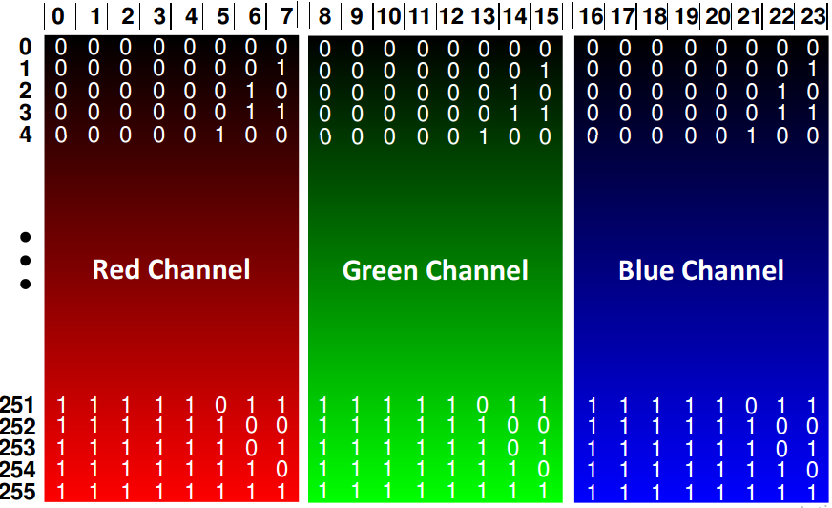

Pixel Number (W x H) • Fixed by standard/device – Mobile: 128 x 96 (sub-quarter CIF) – Videoconferencing: 352 x 288 (CIF) (Common Intermediate Format) – SDTV: 640 x 480 (NTSC) or 720 x 576 (PAL) 5 – HDTV: 1280 x 720p or 1920 x 1080i – WQXGA: 2560 x 1600 • Wide Quad eXtended Graphics Array – Digital Cinema Initiatives (DCI): 24fps • 2K = 2048 x 1080 (also use similar 1920 x 1080 HD format at p24 frame rate) • 4K = 4096 x 2160

Video: Frames Per Second • Depends on application – Time lapse: 1 frame/minute to 1 frame/year – Surveillance: 10 or less – Mobile: 15-20 – Film: 24 6 – SDTV: 25 (PAL) or 30 (NTSC) – HDTV: 25/30 (1920 x 1080) or 50/60 (1280 x 760) – High speed: 100 to 200M per second • 100 frames = 3.33 seconds to playout at 30 fps • 1000 frames = 33.3 seconds to playout at 30 fps • 200M frames >77 days to playout at 30 fps